 | Brunswick South West Primary School
PERSONAL PROPERTY POLICY
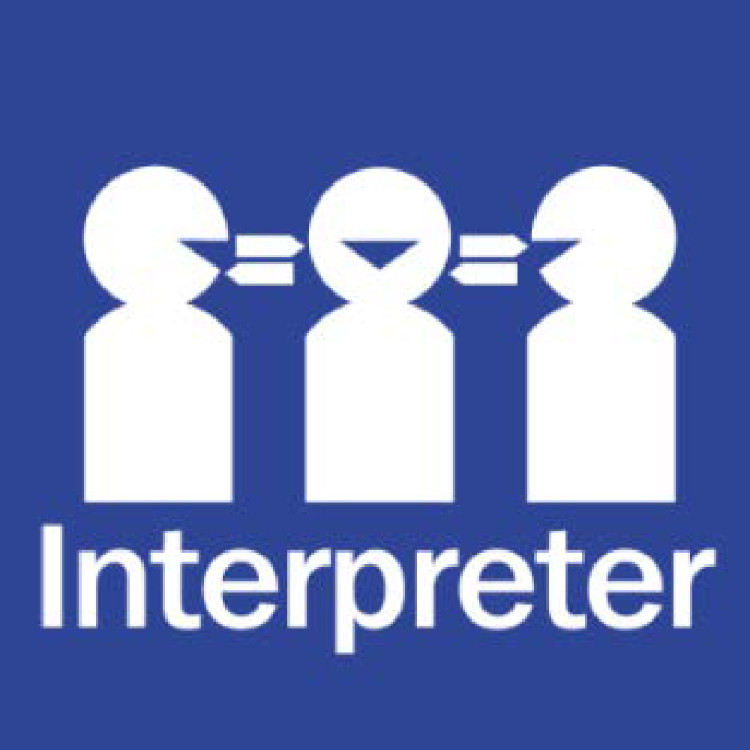
Help for non-English speakers
If you need help to understand the information in this policy please contact the School Office in person or at brunswick.sw.ps@education.vic.gov.au

PURPOSE
To explain Brunswick South West Primary School’s policy in relation to personal property and to ensure that special or valuable items of personal property are not brought to school.

SCOPE
This policy applies to all school activities, including camps and excursions.

POLICY
Brunswick South West Primary School understands that staff and/or students may sometimes like to bring items of personal property to school.
The Department of Education and Training does not have insurance for personal property of staff, students and visitors. Brunswick South West Primary School does not take responsibility for items of personal property that are lost, stolen or damaged at school or during school activities. Damage to personal property brought to school is the responsibility of the owner of that property.
Brunswick South West Primary School encourages staff and students not to bring items of value to school, or to obtain appropriate insurance for such items.
If students bring items of value to school, they will be confiscated and stored securely at the School Office until the end of the day, when the items may be collected by the student and/or parent.

RELATED POLICIES AND RESOURCES
- the Department’s Policy and Advisory Library (PAL):
  - Claims for Property Damage and Medical Expenses
POLICY REVIEW AND APPROVAL
Policy last reviewed | August 2025
Approved by | Principal
Next scheduled review date | August 2029

